*Assessment of the potential of Marinduque Island for Wind and Solar energy*

*MEE 613 Requirement*

Ivan John A. Naparota * ivanjohnnaparota66@gmail.com | Jeffrey Cepedoza * jeffrycepedoza@gmail.com

University of San Carlos – Talamban Campus

Department of Electrical and Electronics Engineering

***Abstract* — this paper presents the assessment of the potential of Marinduque Island for Wind and Solar Energy using Global Solar Atlas and Global Wind Atlas, this paper also offers a design of a hybrid system integrating the said renewable energy sources to the existing diesel power plants in the island.**

# **I. INTRODUCTION**

Marinduque is an island province in the Philippines located in the Southwestern Tagalog Region or MIMAROPA [1]. It belongs to the small power utilities group (SPUG) which is one of the functional groups of the National Power Corporation and is mandated by law to perform the missionary electrification function and shall provide power generation and its associated power delivery systems in areas that are not connected to the main grid [2].

As for the knowledge of everyone, all of the energy consumers in the Philippines are compulsory to subsidize an amount to perform the said missionary electrification which is reflected in our electric bill. So we might ask, are they enjoying a stable energy supply? Are the money of the people not wasted with just a mediocre energy service? We can ensure all of that by discovering the potential of the island for other sources of energy to add up to the existing power plants that can ensure the stability of energy supply.

On the other hand, carbon emission is one of the world’s biggest problem right now, so discovering not only any energy sources but renewable energy sources will greatly help the people in the island without compromising the earth’s well – being.

The authors of this paper used a free access database for solar and wind data which is Global Wind Atlas and Global Solar Atlas to assess the capability of the island for the said renewable energy sources, added to that, HOMER Energy is deployed to design the hybrid system.

# **II. MARINDUQUE**

#### Population and Land Area [3]

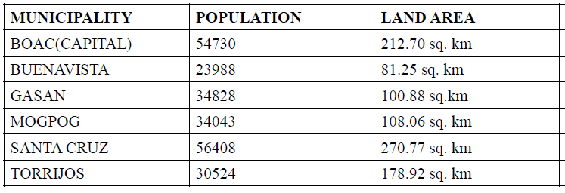

The land area of each municipality of Marinduque is relatively large for an island that is not inhabited that much, this makes Marinduque ideal for location of renewable energy sources knowing that renewable energy farms consume a significant area of land, according to [4], “ a 2-megawatt wind turbine would require a total area of about half a square kilometer”, so imagine the necessary land area if we’ll put up a 50MW wind farm.

#### Existing Power Plants

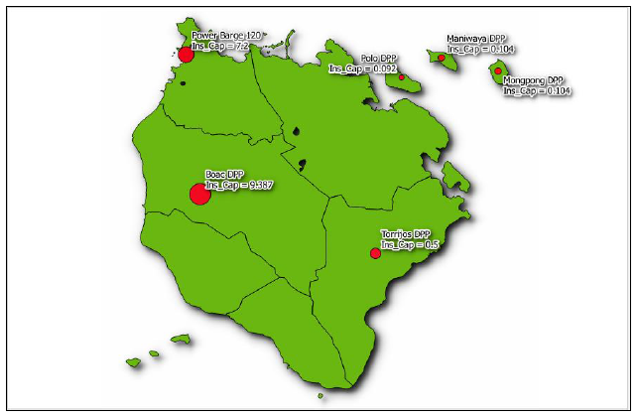

This is the different locations of the existing diesel power plants in the island, the bigger the legend circle the bigger the installed capacity.

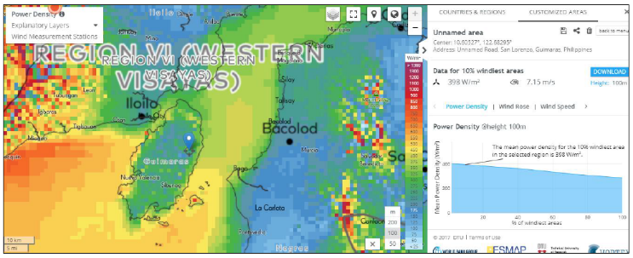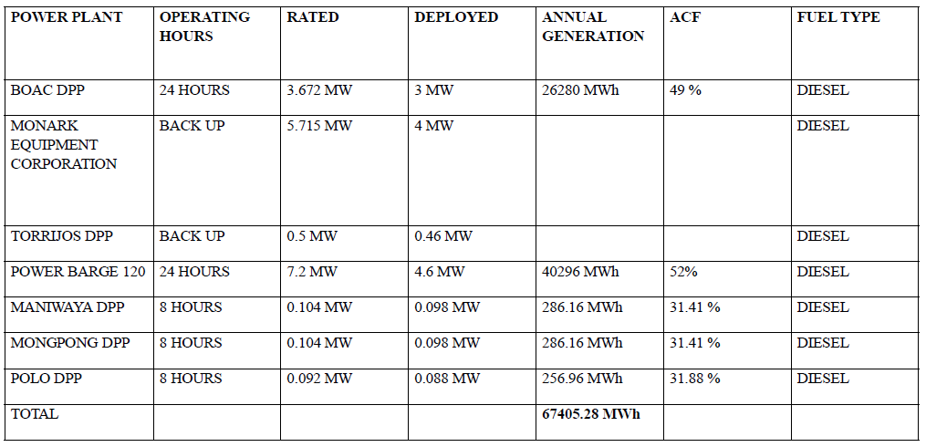

The island entirely rely on diesel power plants for their energy consumption, so it is expected that this will give off a very large amount of carbon for an entire year of operation.

**III. WIND AND SOLAR ASSESSMENT**

1. Wind
   1. Behavior

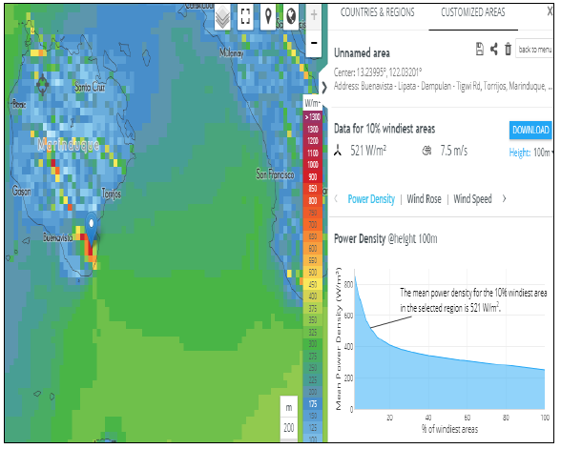 For the whole island, the 10% windiest area has a mean power density of 351 watts per square meter but for a particular area in Buenavista 10km by 10km, it tallies the highest mean power density of 521 watts per square meter at 100m anemometer height.

*Buenavista, Marinduque mean power density*

* 1. Comparison to established Wind Farms
     1. San Lorenzo, Guimaras
        1. *San Lorenzo, Guimaras is the location of one of Philippines’ wind energy farm having an installed capacity of 50MW*
        2. *San Lorenzo has a mean power density of 398 watts per square meter which is relatively lesser than of the recorded mean power density of Marinduque*
     2. Nabas, Aklan
        1. *36 MW wind energy source is located in Nabas, Aklan*
        2. *Mean power density due to wind in Nabas, Aklan is relatively larger than of Marinduque’s but it does not have that much of a difference*

Marinduque’s potential for wind energy source is noticeable and proposing a wind energy farm in Buenavista, Marinduque is reasonable for it has the biggest mean power density across the region of Marinduque. Added to that, Marinduque’s potential for wind energy source is complemented by its large land area, Buenavista has a land area of 81.25 sq. km and according to [4], “a 2-megawatt wind turbine would require a total area of about half a square kilometer”, making it more desirable to put the wind energy farm in Buenavista, Marinduque.

1. 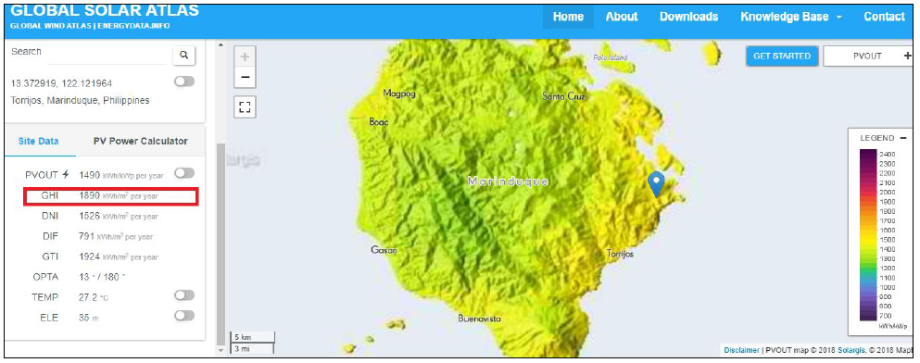Solar

It is observable in the GUI of Global Solar Atlas that Torrijos, Marinduque has the largest Global Horizontal Irradiance across the Marinduque region, it has a high potential for solar energy having a GHI of 1886 kWh per square meter. More to that is the fact that it is located in Torrijos, it is favorable that Torrijos would be the place for the solar farm because the municipality has the least population density of only 170 persons per square kilometer [3] and having a very large land area of 178.92 square kilometer [3].

**IV. HYBRID SYSTEM DESIGN**

A. Wind and Solar Data

Buenavista, Marinduque Wind Data (m/s)

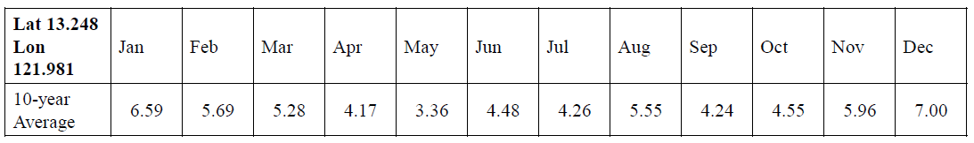

Torrijos, Marinduque Horizontal Insolation (kWh/m2/day)

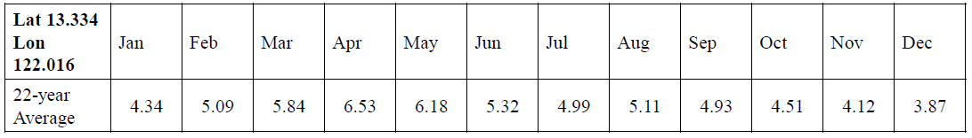

B. HOMER Simulation

a. Specifications of components

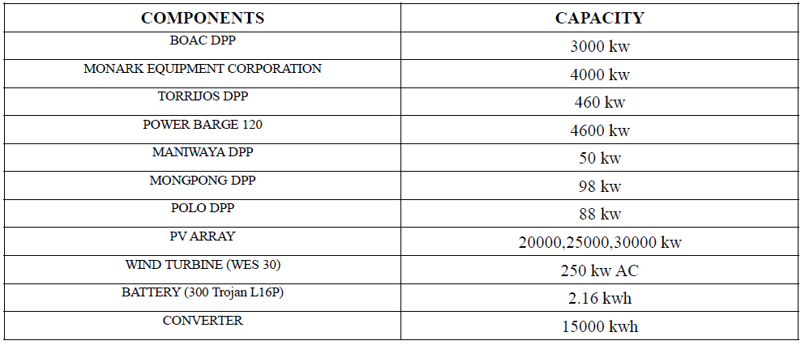

b. Existing diesel power plants

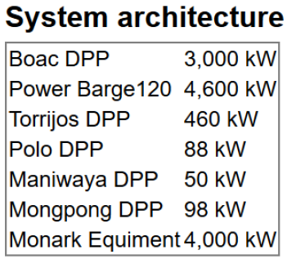

**Results:**

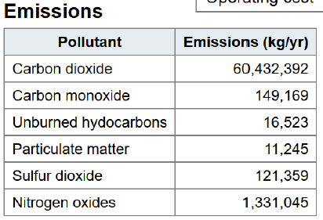 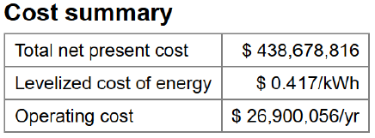

c. Proposed Hybrid System (HOMER Optimized)

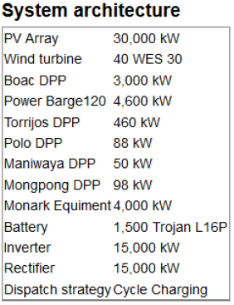

**Results:**

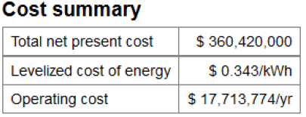

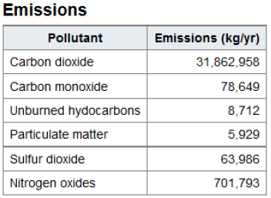

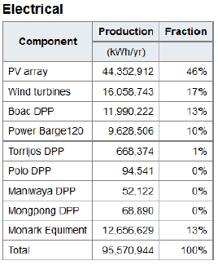

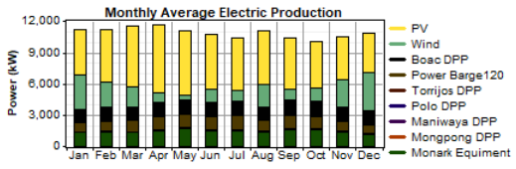

**V. DISCUSSIONS**

The results from HOMER which are presented shows that the optimized hybrid system is composed of generally a 30 MW solar energy source and a 10 MW wind energy source, it is observable that it limits the usage of existing diesel power plants to only 37 % of the total energy consumption of the island, resulting in a lesser carbon emission which is about half of the total carbon emission of the existing diesel power plants in the island, and surprisingly, the levelized cost of energy became lesser with the proposed hybrid system, from $ 0.417 to $ 0.343.

**VI. CONCLUSIONS**

* Practicing the use of renewable energy is of big help in addressing the problem in excessive emission of carbon dioxide to the atmosphere.
* The island of Marinduque has a high potential for solar and wind energy.

**VII. REFERENCES**

1. https://en.wikipedia.org/wiki/Marinduque
2. https://www.spug.ph/index.php/frequently-ask-questions
3. Census of Population (2015).Highlights of the Philippine Population 2015 Census of Population.PSA. Retrieved20 June2016

##### 